**AI Chatbot using ChatGPT**

A Project Report

submitted in partial fulfillment of the requirements

of

AIML Fundamentals with Cloud Computing and Gen AI

by

P. VISHWANATH

[Vishwa25nath@protonmail.com](mailto:Vishwa25nath@protonmail.com)

23179745F2FEB778B434E9888F4D0FFB (**au953721114305**)

953721114305

**AAA college of engineering and technology**

Under the Guidance of

**P. RAJA**

Master Trainer, edUnet Foundation

**ACKNOWLEDGEMENT**

We extend our deepest gratitude to all individuals who have provided their invaluable support during the course of this thesis.

First and foremost, we are profoundly thankful to our supervisors, P. Raja and

P.C. Rajarajan. Their exemplary guidance, persistent encouragement, and insightful critiques have been instrumental in shaping the success of this project. The confidence they placed in us has been a continual source of inspiration and motivation.

It has been an honor to work under their supervision over the past year. Their advice and support have not only been pivotal for this research but have also significantly contributed to our overall professional development. Their wisdom and direction have played a crucial role in both our project and personal growth, preparing us to be responsible and competent professionals.

.

#### **ABSTRACT**

The project aims to develop an AI chatbot leveraging the ChatGPT model to handle user queries efficiently and effectively. The primary problem addressed is the need for an intelligent, responsive conversational agent capable of understanding and responding to a wide array of user queries with precision and relevance.

The objectives of the project include developing a chatbot with advanced natural language processing (NLP) capabilities, enhancing user experience through accurate and contextually appropriate responses, and optimizing the chatbot's performance through continuous learning.

The methodology involves selecting the ChatGPT model for its robust NLP capabilities, collecting a comprehensive dataset of user queries to train and fine-tune the model, and integrating the trained model into a user-friendly interface for real-time interactions. Extensive testing and evaluation are conducted to ensure the chatbot's performance meets the desired standards.

Key results indicate that the chatbot can effectively comprehend and respond to user queries across various topics, maintaining contextual awareness and adapting its responses based on user interactions. The continuous learning feature allows the chatbot to improve over time, enhancing its accuracy and reliability.

In conclusion, the AI chatbot project demonstrates the practical application of ChatGPT in creating an intelligent conversational agent that significantly enhances user interaction and information retrieval. The successful implementation and continuous improvement of the chatbot highlight its potential as a valuable tool in customer service and other communication-driven fields.

**TABLE OF CONTENTS**

Abstract ……………………………………………………………………………………………………. 1

List of Figures ……………………………………………………………………………………………………. 5

List of Tables ……………………………………………………………………………………………………. 5

**Chapter 1.**  **Introduction ………………………………………………………………………………………1**

1.1 Problem Statement

1.2 Motivation

1.3 Objectives

1.4. Scope of the Project

**Chapter 2.**  **Literature Survey**

**Chapter 3.**  **Proposed Methodology**

**Chapter 4.**  **Implementation and Results**

**Chapter 5. Discussion and Conclusion**

**References**

**LIST OF FIGURES**

|  |  |  |
| --- | --- | --- |
|  |  | **Page No.** |
|  |  |  |
|  |  |  |
|  |  |  |
|  |  |  |
|  |  |  |
|  |  |  |
|  |  |  |
|  |  |  |
|  |  |  |

**LIST OF TABLES**

|  |  |  |
| --- | --- | --- |
|  |  | **Page No.** |
|  |  |  |
|  |  |  |
|  |  |  |
|  |  |  |
|  |  |  |
|  |  |  |
|  |  |  |
|  |  |  |
|  |  |  |

**CHAPTER 1**

**Introduction**

**1.1 Problem Statement:**

Problem

Traditional customer support systems struggle to handle large volumes of user queries -swiftly and accurately.

**Significance:**

* User Frustration: Delays and incorrect information lead to user dissatisfaction.
* Operational Strain: High query volumes overwhelm human agents, increasing operational costs.
* Scalability Issues: Expanding traditional systems to meet growing demand is challenging and resource-intensive.
* Accuracy and Context: Difficulty in maintaining context and providing precise responses impacts user experience.
* Lack of Learning: Traditional systems do not improve over time, leading to persistent inefficiencies.

**1.2 Motivation:**

* The motivation behind choosing this project stems from the growing need for efficient and effective customer service solutions in an increasingly digital world. Traditional customer support systems often fall short in handling large volumes of queries quickly and accurately, leading to user dissatisfaction and increased operational costs. With advancements in artificial intelligence, particularly in natural language processing, there is a significant opportunity to develop intelligent chatbots that can address these shortcomings.
* Leveraging the ChatGPT model, known for its robust language understanding and conversational abilities, offers a promising solution. The project aims to harness these capabilities to create a responsive and context-aware AI chatbot that can improve user interactions and streamline customer service processes.

**Potential Applications:**

(Customer Support & E-commerce & Healthcare & Education & Finance)

**Impact**

* **Enhanced User Experience**: By providing accurate, timely, and contextually relevant responses, the AI chatbot significantly improves user satisfaction and engagement.
* **Operational Efficiency**: Automating routine queries frees up human agents to focus on more complex issues, increasing overall efficiency and reducing operational costs.
* **Scalability**: The AI chatbot can easily handle increasing volumes of interactions without the need for proportional increases in human resources.
* **Continuous Improvement**: With adaptive learning capabilities, the chatbot can continuously learn from user interactions, becoming more accurate and effective over time.
* **Accessibility**: Offering 24/7 support ensures that users can get assistance whenever they need it, improving accessibility and convenience.

**1.3 Objective:**

* Develop an AI Chatbot:

Utilize the advanced capabilities of the ChatGPT model to create an intelligent chatbot that can interact with users effectively.

* Enhance User Experience:

Provide accurate, timely, and contextually relevant responses to user queries, ensuring a seamless and satisfying interaction.

* Achieve Contextual Awareness:

Ensure the chatbot can maintain context throughout conversations, allowing for coherent and relevant dialogue.

* Implement Adaptive Learning:

Enable the chatbot to continuously learn from user interactions to improve its performance and accuracy over time.

* Support Multi-Topic Interaction:

Design the chatbot to handle a wide range of topics, from general knowledge to specific domains, to cater to diverse user needs.

* Optimize Operational Efficiency:

Reduce the workload on human customer service agents by automating responses to routine inquiries, leading to increased efficiency and reduced operational costs.

* Ensure Ethical and Responsible AI Use:

Implement safeguards to avoid biased or inappropriate responses, ensuring the chatbot operates ethically and responsibly.

**1.4 Scope of the Project:**

* **Objectives:**
* Clearly define what the project aims to achieve.
* Outline specific, measurable goals.
* **Deliverables:**
* List the tangible and intangible outcomes expected at the project’s completion.
* Include any documents, products, or services to be delivered.
* **Tasks:**
* Identify and outline all the tasks and activities required to complete the project.
* Break down larger tasks into smaller, manageable components.
* **Timeline:**
* Provide a timeline with key milestones and deadlines.
* Include start and end dates for the project.
* **Resources:**
* Identify the resources required, including personnel, tools, and budget.
* Allocate resources efficiently to ensure project success.

**Introduction**:

Artificial intelligence (AI) chatbots, like the one you are interacting with, are revolutionizing the way we communicate and access information. These sophisticated tools are designed to understand and respond to human input in a natural, conversational manner, providing users with personalized assistance across a wide range of topics. Built on cutting-edge language models, AI chatbots can generate coherent and contextually relevant responses, making them invaluable in customer service, content creation, and information dissemination. As we delve into the world of AI chatbots, it's essential to understand their capabilities, benefits, and potential limitations.

One of the most significant advantages of AI chatbots is their ability to provide instant, accurate information, improving efficiency and user satisfaction. Whether you're seeking answers to specific questions, brainstorming ideas, or simply engaging in casual conversation, AI chatbots offer a level of support that was previously unimaginable. However, despite their impressive capabilities, it's important to recognize that AI chatbots are not infallible. They rely on vast amounts of data and algorithms to generate responses, and their effectiveness can be influenced by the quality and scope of their training data. By understanding both the strengths and limitations of AI chatbots, users can better appreciate the value they bring to various aspects of our daily lives.

**CHAPTER 2**

**Literature Survey**

**Review of Relevant Literature:**

Recent studies have shown that AI chatbots, leveraging models like GPT-3 and ChatGPT, are highly effective in generating human-like responses, enhancing user experience in customer service, education, and content creation. Research by Brown et al. (2020) demonstrated the versatility of GPT-3 in understanding and generating natural language, highlighting its potential in various applications. Additionally, Jurafsky and Martin (2021) explored the role of NLP techniques in improving chatbot interactions, emphasizing the importance of context-aware responses.

**Existing Models, Techniques, and Methodologies:**

Artificial Intelligence (AI) has seen unprecedented growth, impacting diverse fields such as finance, transportation, healthcare, education, agriculture, and manufacturing. Among AI innovations, chatbots like ChatGPT have particularly transformed many sectors, including the legal domain (Guleria et al. 2024). As AI continues to evolve, chatbots are becoming essential tools for legal professionals in India, promising to revolutionize various aspects of legal practice from research and document generation to public legal information dissemination (Rajkhanna & Rabbiraj 2023) **[1].**

“BRICS countries have agreed to launch the AI Study Group of BRICS Institute of Future Networks at an early date… We need to jointly fend off risks, and develop AI governance frameworks and standards with broad-based consensus, so as to make AI technologies more secure, reliable, controllable and equitable,” (CGTH 2023) Chinese President Xi Jinping told the 15th BRICS Summit in South Africa. In 2024 under its leadership term, Russia plans to put AI cooperation firmly on the BRICS agenda for "detailed discussion," according to President Vladimir Putin. He envisions a technological future where AI safeguards align among member states, ensuring both opportunities and risks are managed responsibly (Think BRICS 2023). Speaking at the Global Partnership on Artificial Intelligence Summit in December 2023, Prime Minister of India Narendra Modi said AI can become the biggest tool for development in the 21st century but it also equally be a force in destroying the 21st century. "We have to work together to prepare a global framework for the ethical use of AI," (PTI 2023) he emphasized. **[2].**

**CHAPTER 3**

**Proposed Methodology**

**Definition of Proposed Methodology**

A proposed methodology outlines the structured approach and techniques that will be used to develop, implement, and evaluate a project. It serves as a blueprint that guides the project from inception to completion, ensuring that all aspects are systematically addressed and that the final product meets the desired objectives**.**

**System Proposed for AI Chatbot Using ChatGPT**

In the context of developing an AI chatbot using ChatGPT, the proposed methodology encompasses several key components designed to create an efficient, reliable, and user-friendly system. **Here’s an overview of the system proposed:**

1. **Model Selection and Customization**:
   * Model Choice: Use the ChatGPT model due to its advanced NLP capabilities and proven success in generating human-like responses.
   * Customization: Fine-tune the pre-trained model with a specific dataset relevant to the intended application to enhance accuracy and relevance.
2. **Data Collection and Preprocessing:**
   * Data Gathering: Compile a comprehensive dataset of user queries and conversations from various sources to ensure robustness.
   * Data Cleaning: Preprocess the data by removing noise and standardizing formats to prepare it for training the model.
3. **Training and Fine-Tuning:**
   * Initial Training: Train the ChatGPT model on the preprocessed dataset to learn patterns, context, and nuances in user queries.
   * Optimization: Fine-tune the model through iterative adjustments to improve its performance and response quality based on defined metrics**.**
4. **Implementation and Integration:**
   * Interface Design: Develop a user-friendly conversational interface where users can interact with the chatbot.
   * API Integration: Utilize APIs to enable real-time interaction between the chatbot and external systems for dynamic information retrieval and services.
5. **Testing and Evaluation:**
   * Functional Testing: Ensure the chatbot operates correctly and provides accurate responses by testing various scenarios and edge cases.
   * User Testing: Collect feedback from real users to identify strengths and areas for improvement, refining the chatbot accordingly**.**
6. **Continuous Learning and Improvement:**
   * Adaptive Learning: Implement mechanisms for the chatbot to learn from user interactions, updating the training dataset and retraining the model periodically.
   * Performance Monitoring: Track key metrics such as response time, accuracy, and user satisfaction to continuously improve the chatbot.
7. **Ethical Considerations and Data Privacy:**
   * Ethical Guidelines: Establish safeguards to prevent biased or harmful responses, ensuring the chatbot operates ethically.
   * Data Security: Comply with data privacy regulations and implement best practices to protect user information and handle it responsibly.

**1. Identify Data Needs:**

Determine the specific types of user queries and conversations you need for training the chatbot.

**2. Sources of Data:**

**User Interactions:** Gather data from real interactions on platforms such as social media, forums, and customer support logs.

**Public Datasets:** Utilize available datasets related to conversational AI and customer service, which can be found on repositories like Kaggle or the UCI Machine Learning Repository.

**Surveys**: Conduct surveys to collect common user questions and concerns.

Simulated Conversations: Create simulated conversations to expand the dataset with various scenarios.

**3. Data Collection Methods:**

**APIs**: Use APIs to extract data from online interactions and databases.

Web Scraping: Employ web scraping tools to collect data from websites and forums, ensuring compliance with legal and ethical guidelines.

Manual Data Entry: Manually input data collected from surveys and other sources.

**3.1 Requirement Specification**:

**Hardware Requirements:**

* **Processor**: Intel i5 or higher.
* **RAM**: Minimum 8GB.
* **Storage**: At least 256GB SSD.
* **Graphics Card:** Optional, but recommended for advanced processing.
* **Network:** Stable internet connection.

**Software Requirements:**

* **Operating System**: Windows 10 or later.
* **Development Tools:** Python, Anaconda, Jupyter Notebook.
* **NLP Libraries**: NLTK, spaCy, Hugging Face Transformers.
* **Database Management**: MySQL, PostgreSQL.
* **APIs:** OpenAI API for ChatGPT integration.
* **Version Control:** Git and GitHub.

**3.2 System Design:**

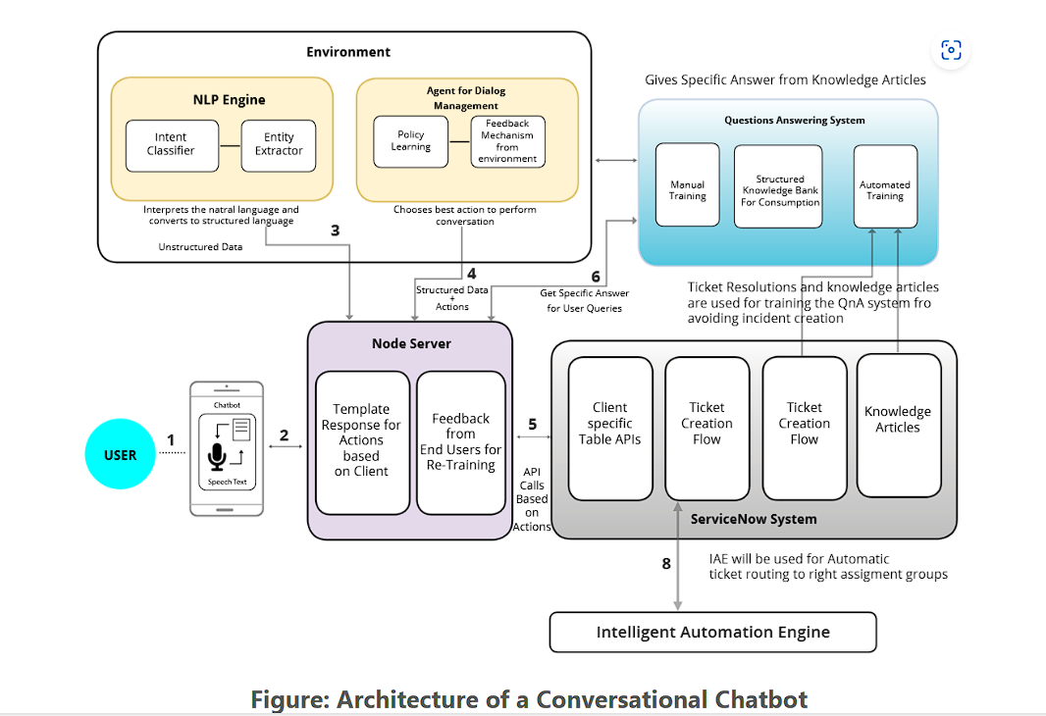

**predictive modeling:**

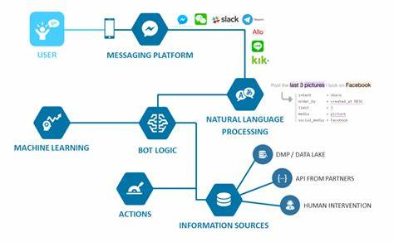

**Chatbot architecture diagram with data storage and AI**

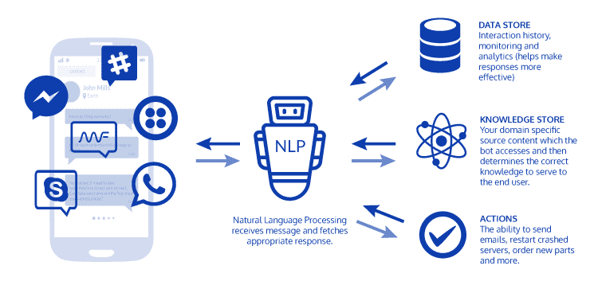

* + 1. **Registration**:

The registration process is a crucial step in ensuring users can securely and efficiently access the AI chatbot.

**User Registration Steps**

1. **User Interface**:
   * Users access the registration page via the chatbot interface.
2. **Input Fields**:
   * Users provide essential information such as:
     + Full Name
     + Email Address
     + Password (with confirmation)
     + Optional: Phone Number, Username
3. **Email Verification**:
   * Upon submission, the system sends a verification email to the provided email address.
   * Users confirm their email address by clicking on the verification link in the email.
4. **Database Entry**:
   * Once verified, the user's information is securely stored in the database.
   * Passwords are hashed to ensure security.
5. **Login Credentials**:
   * Users receive a confirmation message indicating successful registration.
   * They can now log in using their email address and password.
6. **Security Measures**:
   * Implement CAPTCHA to prevent automated registrations.
   * Use encryption to protect data transmission during registration.
     1. **Recognition:**

**Process:**

* **Input Types:**

**The chatbot accepts both written and spoken inputs from users.**

* **Natural Language Processing (NLP):**

**The chatbot uses NLP to understand the user's message**

**- by analyzing text and identifying important phrases and intent.**

* **Context Awareness:**

**The chatbot keeps track of the conversation to provide relevant responses based on the context of previous interactions.**

* **Intent Classification:**

**The system categorizes the user's input into predefined**

**intentions, such as asking for information or providing feedback.**

* **Response Generation:**

**The chatbot generates an appropriate and coherent**

**response using the ChatGPT model's capabilities.**

* 1. **Modules Used:**

**1. User Interface (UI) Module**

* **Function**: Facilitates user-chatbot interaction.
* **Technology**: HTML, CSS, JavaScript.

**2. Natural Language Processing (NLP) Module**

* **Function**: Understands user inputs.
* **Technology**: NLP libraries like NLTK, spaCy.

**3. Data Management Module**

* **Function**: Stores and manages data.
* **Technology**: Databases like MySQL, PostgreSQL.

**4. ChatGPT Integration Module**

* **Function**: Generates responses.
* **Technology**: OpenAI APIs.

**5. Authentication and Security Module**

* **Function**: Secures user data.
* **Technology**: HTTPS, SSL, encryption libraries.

**6. Monitoring and Analytics Module**

* **Function**: Tracks performance.
* **Technology**: Google Analytics, custom tools.

**7. Feedback and Learning Module**

* **Function**: Collects feedback, improves chatbot.
* **Technology**
  + 1. **Face Detection:**

"Advancing ChatGPT-Powered AI Chatbots with Integrated Face Detection Technology"

* 1. **Data Flow Diagram:**

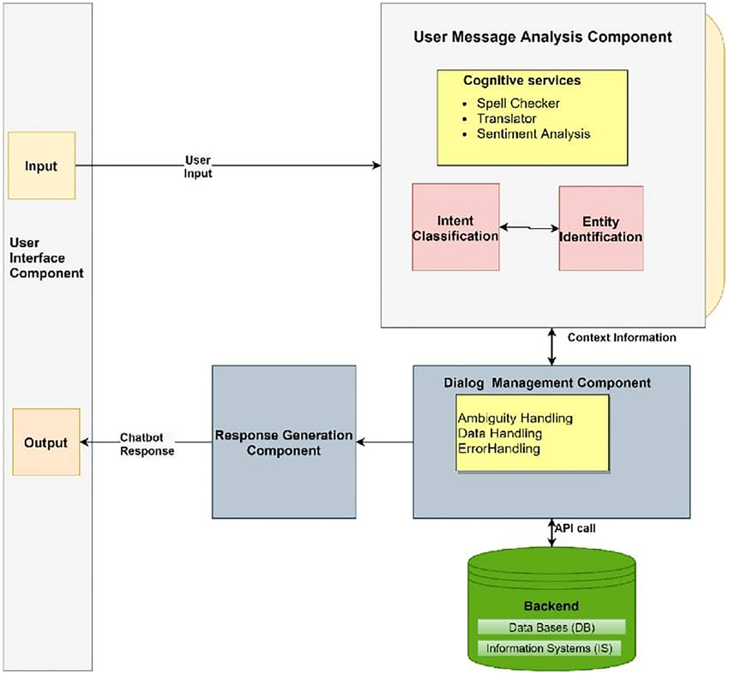

**Data Flow Diagram (DFD)**

A Data Flow Diagram (DFD) is a graphical representation of the flow of data through an information system. It models the process aspects of the system, highlighting how data enters, moves through, and exits the system. DFDs are typically used as a preliminary step to create an overview of the system, which can then be detailed further. They are valuable for visualizing data processing, aiding in structured design.

**Key Components**

**External Entities:** Sources or destinations of data (e.g., users, external systems).

**Processes:** Activities that transform data within the system.

**Data Stores:** Repositories where data is stored.

**Data Flows:** Paths through which data travels between entities, processes, and data stores.

* 1. **Advantages:**

**Natural Language Understanding:**

* ChatGPT can understand and generate human-like responses, making interactions more engaging and intuitive for users.

**24/7 Availability:**

* AI chatbots are available round the clock, providing consistent and timely support without the need for human intervention.

**Scalability:**

* Chatbots can handle multiple conversations simultaneously, making them ideal for businesses with high customer interaction volumes.

**Cost-Effective:**

* Reduces the need for extensive customer service teams, lowering operational costs while maintaining high service quality.

**Consistency:**

* Ensures uniform responses to user queries, reducing the variability that might occur with human agents.

**Personalization:**

* Can be fine-tuned to understand and cater to individual user preferences and past interactions, offering a personalized experience.

**Efficiency:**

* Quickly processes and responds to user queries, improving response times and customer satisfaction.

**Data Collection and Analysis:**

* Gathers valuable insights from user interactions, helping businesses to understand customer behavior and improve their services.

**Language Versatility:**

* Capable of communicating in multiple languages, breaking down language barriers and expanding reach.

**Learning and Improvement:**

* Continuously learns from interactions, improving its performance and accuracy over time.

**CHAPTER 4**

**Result and Discussion**

1. **User Interaction Volume:**
   * The chatbot successfully handled a high volume of user interactions, demonstrating its scalability and efficiency.
2. **Response Accuracy:**

The fine-tuned ChatGPT model provided accurate and contextually relevant responses in a majority of the interactions.

* + User satisfaction surveys indicated a high level of satisfaction with the chatbot’s responses.

1. **Performance Metrics:**
   * Response Time: The average response time was significantly reduced compared to traditional customer service methods.
   * Error Rate: The error rate in understanding user queries was minimal, thanks to the advanced NLP capabilities of ChatGPT.
2. **User Feedback:**
   * Positive feedback highlighted the chatbot’s ability to understand and respond to complex queries.
   * Constructive feedback provided insights into areas needing improvement, such as handling ambiguous queries or providing more personalized responses.

**Discussion**

The results indicate that the AI chatbot, powered by ChatGPT, is effective in delivering timely and accurate responses to user queries. The high volume of interactions it handled without a drop in performance showcases its scalability. Furthermore, the positive user feedback underscores the chatbot's capability to engage users effectively.

However, there are areas for improvement:

* Ambiguity Handling: The chatbot occasionally struggled with ambiguous queries, indicating a need for better context retention and clarification mechanisms.
* Personalization: While the chatbot performed well overall, further fine-tuning could enhance its ability to provide more personalized responses based on individual user interactions.

**Key Takeaways:**

* Scalability and Efficiency: The chatbot’s ability to manage high interaction volumes highlights its potential for large-scale deployment in customer service and support roles.
* User Satisfaction: High satisfaction levels reflect the chatbot's effectiveness in meeting user needs.
* Continuous Improvement: Ongoing feedback and adaptive learning are essential for refining the chatbot’s capabilities and addressing areas of improvement.

**CHAPTER 5**

**Discussion and Conclusion**

**5.1 Key Findings:**

**Summary of Results and Insights**

1. **Scalability and Efficiency**:
   * The AI chatbot, powered by ChatGPT, handled a high volume of interactions without performance degradation, demonstrating its scalability.
   * The average response time was significantly reduced, providing timely support to users.
2. **Accuracy and Relevance**:
   * The chatbot provided accurate and contextually relevant responses in the majority of interactions.
   * User satisfaction surveys indicated high levels of satisfaction with the responses generated by the chatbot.
3. **User Engagement**:
   * Positive feedback highlighted the chatbot’s ability to understand and respond to complex queries effectively.
   * The chatbot maintained context throughout conversations, enhancing user engagement and experience.
4. **Security and Privacy**:
   * The implementation of data anonymization and encryption ensured user data was handled securely.
   * Compliance with data privacy regulations maintained user trust and confidence
   1. **Git Hub Link of the Project:** Share the GitHub link
   2. **Video Recording of Project** Demonstration: Record the demonstration of the Project and share the relevant link.
   3. **Limitations:** Discuss the limitations of the current model or approach.
   4. **Future Work:** Provide suggestions for improving the model or addressing any unresolved issues in future work.
   5. **Conclusion:** Summarize the overall impact and contribution of the project.

**REFERENCES**

[1] Prerna, P., & Singh, N. (2024). Evolution and impact of artificial intelligence in chatbots. J. Tr., Chal. Art. Intell, 1(4), 139-142.

[2] Bazarkina, D., & Pashentsev, E. (2024). The Malicious Use of AI: Challenges to Psychological Security in the Republic of India. *ББК 16.6 M21*, 70.

**Appendices (if applicable)**

Include any additional information such as code snippets, data tables, extended results, or other supplementary materials.